**Chapter 4**

**RESULTS AND DISCUSSION**

**Project Technical Description**

The Employee Task Management System and Capacity Resource Analysis dashboard is an integration of two business solution software for Digital Marketing team. Developed as a desktop software application to collect in progress, in coming and past employee activities and automatically push to another application to provide real time employee capacity as well as capacity projection against the forecasted load via Microsoft Power BI Services. Below are the specific functions of the solution addressing the business problem and requirements:

1. *Desktop Application Software*. The software is capable of capturing and managing employee existing task for the current day or week as well as their planned activities for future dates. It provides users with a wide range of capabilities and tools integrated to other Microsoft Office products to help them work more efficiently, creatively, and effectively. The software is flexible to function in a hybrid work set up where users can work both in the office without finding any trouble in an event of internet disruption. Since it is not a web-based application, internet connection is not much of a requirement unless there’s a need of uploading and downloading utilization data. Stakeholder’s requirement is to enable user to continuously log their time spent for every marketing activity without major dependency via a network. Having this approach enable users to track and provide actual and accurate activity records for the management. Furthermore, this software application only run through a Windows Operating System as the official OS of business wide. It has also the capability to detect any task left activated and automatically hold active/running task to ensure data integrity whenever a user is away from his/her keyboard and once laptop automatically in a sleep of off mode.
2. *Task Management*. A task management helps individuals and teams to plan, log, track, and manage their daily activities and projects. Task management capabilities covers the end-to-end process of an activity. Among those features is the capability of a system to allow users manage their utilization by Logging and organizing tasks where they can create new tasks, set due dates, assign tasks to specific team members, and prioritize tasks based on importance. In addition, it also allows users to track the progress of each task by activating and holding concurrent activities, monitor the time spent and complete whenever it's done. It also has the features to efficiently switch between tasks in just a quick of a button that automatically get the time interval between the previous and the active task. The system can integrate with other tools, such as outlook email, calendars, and other company portals, to streamline workflows and improve productivity. Overall, a task management system provides a centralized and organized way to manage tasks efficiently.
3. *Attendance and Time offs.* Another system's feature that allows the team to track employee attendance, time off, and other related information. It captures employee clock in for the day and require them to log leaves with or without pay such as vacation, sick leave, maternity, and other time offs. In addition to this, attendance and leave records are also part of the utilization rate equation to calculate the and exclude leaves from the overall utilization capacity of a team or individual. The way it works for users is accessing the attendance and leave form to fill in the date, description, and other remarks where attendance and leave is related.
4. *Local and Uploaded Records.* Holds both historical records of employee utilization data. Local records are data that serves as a back-up data stored in user’s machine. This is the initial repository of all the activities a user has before it will be shared to a central database via Azure SQL data warehouse. Data are kept locally and has a status of local until it changed to uploaded once shared to the Azure SQL Database. This approach supports the capability of the tool to function well even in the absence of a network connection and to optimize the speed of system’s functionality.
5. *Activity Configuration.* This module allows admin users to add, modify and remove marketing activities whenever there is an updates or changes needs to reflect from users end. Only admin users can access the module as part of security features.
6. *Requestor Management*. All job request needs to have a reference list of who and where the task came from. Requestor name, service line and rank will be manage in this module.
7. *Resource Capacity Dashboard*. A resource capacity dashboard is a business intelligence tool developed from MS Power BI application. It serves as the main and true source of utilization reporting. This function is designed to monitor and manage team resources', availability, and utilization levels. It provides a visual representation of the current and projected capacity of a team or an individual resources, such as marketing managers and marketing staff. Leaders will investigate this dashboard to understand employee capacity to support as well as to better optimize workforce for an effective service delivery. The dashboard automatically displays data in real-time through a scheduled refresh that was configured in Power BI Web services to allow managers to quickly identify potential bottlenecks, allocate resources more efficiently, and make informed decisions about project pipelines, staffing, and budgets. It can also help identify trends and patterns in resource utilization over time, enabling leaders to make data-driven decisions about resource planning and investment. In summary, a resource capacity dashboard is the single source of truth for business leaders that drive operational efficiency and support business goals.

**Use Case of the System**

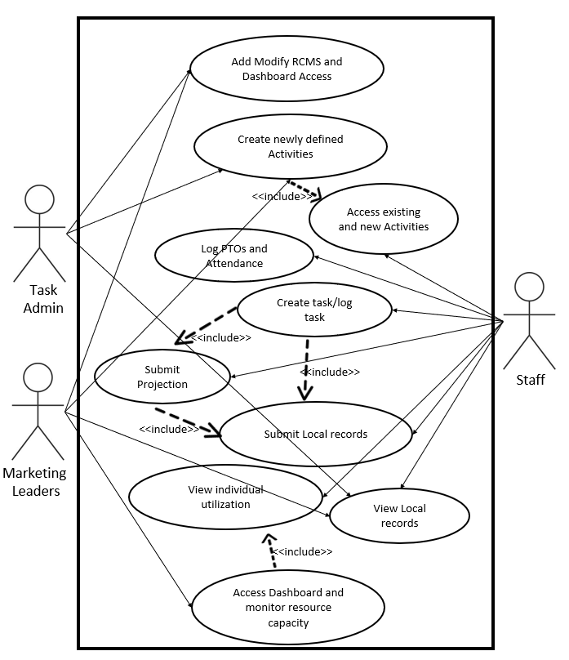

**Figure 4.1** *Use Case Diagram of the Developed System*

**User Story**

1. **Use Case Title**: Add Modify RCMS and Dashboard Access

**Description**: The Task Administrator and Manager can add and modify user access of the system and the dashboard.

**Primary Actor**: Task Administrator /Marketing Leaders

**Goal**: To allow users access the system and data audience to view the dashboard.

**Pre-Conditions**: Before doing an update, the admin must log in to the system and ensure he’s connected to the company’s private network.

**Post-Conditions**: Updated access will be provided to users and data audience.

**Table 4.1** *Use Case Scenario of Add Modify RCMS and Dashboard Access*

|  |  |
| --- | --- |
| **Actor** | **System** |
| 1. Access the system.  3. Add and modify user access. | 2. Validates user account.  4. Updates user access.  5. Display confirmation message. |

It is shown in table 4.1 the processes how to add and modify user and user’s access of Staff, Task Admin and Marketing leaders. This process is relevant, especially in case there is a change in the organization structure. The main role of the task administrator is to manage the system’s settings and maintenance.

1. **Use Case Title**: Create newly defined Activities

**Description**: The Task Administrator will add new activities from the main server using the system whenever there is a newly defined task by the leaders in collaboration with managers and staff.

**Primary Actor**: Task Administrator

**Goal**: To add newly defined activities so that users can sync the new task to their local records and access it when there’s a need to add or log new task.

**Pre-Conditions**: Before doing an update, the admin must log in to the system and ensure he’s connected to the company’s private network.

**Post-Conditions**: New Activity will be added to existing list of Activities to the main database and will be ready for all staff to sync to their local records.

**Table 4.1** *Create newly defined Activities*

|  |  |
| --- | --- |
| **Actor** | **System** |
| 1. Access the system.  3. Add new Activity | 2. Validates user account.  4. Updates activity records.  5. Display confirmation message. |

It is shown in table 4.1 the processes how to add newly defined activity for users’ utilization. This is vital to the organization to measure new service offering they have for the partner organization as well as to the internal teams where they collaborate and manage work. The role of the task administrator is to manage both existing and new activity.

1. **Use Case Title**: Access existing and new Activities

**Description**: Newly added activity in the main database needs to be in user’s local records. The newest activity will reflect to all users and can be found in the creation of new task.

**Primary Actor**: Staff

**Goal**: To update the list of existing activities from the user’s local records through syncing of the data from the main database.

**Pre-Conditions**: Before doing an update, the staff must log in to the system and ensure he’s connected to the company’s private network. Check the list of existing activities in the record.

**Post-Conditions**: New activity will be added, and the list will be updated and ready for all users to select for task creation.

**Table 4.1** *Use Case Scenario of Access existing and new Activities*

|  |  |
| --- | --- |
| **Actor** | **System** |
| 1. Access the system.  3. Go to Settings/Activity  5. Refresh and Sync | 2. Validates user account.  4. Open and retrieve activities from local record.  6. Local records table for activities will be updated. |

It is shown in table 4.1 the processes how to sync and update user’s local records of activities to ensure they also capture the new type of work they can provide to the business stakeholders. Staffs are required to monitor the list of activities they have and come up with an idea to discuss activities that are out of scope and bring it to the attention of leaders if there’s a need to define new activity with specific requirements and deliverables.

1. **Use Case Title**: Log PTOs and Attendance

**Description**: Logging of the daily time in and leaves of users to the system. PTO stands for Paid time off.

**Primary Actor**: Staff

**Goal**: To log and capture user attendance and leaves that are essential for the target hours and a critical factor to calculate the utilization rate of a staff.

**Pre-Conditions**: Before logging the attendance and PTOs, the staff must log in to the system. It is not necessary to connect to the company’s private network yet —hence attendance and PTO data will be stored initially to user’s local records.

**Post-Conditions**: Attendance will be added to user’s local records and will be ready for upload anytime of the day same as their PTOs.

**Table 4.1** *Use Case Scenario of Log PTOs and Attendance*

|  |  |
| --- | --- |
| **Actor** | **System** |
| 1. Access the system.  3. Go to Attendance Module and select Time in  5. Select mood for the day.  6. Add remarks if needed i.e., notes or reason for being late.  7. Submit attendance  9. Go to Attendance Module and select Out of Office.  11. Select leave date, remarks, and the corresponding hours of leave. 8hr for each day if it’s a whole day leave – hence 4hs if taking a half day leave. | 2. Validates user account.  4. Open and retrieve attendance from local record.  6. An auto response message will pop up depends on the mood selected.  8. Attendance will be added to the local records.  10. Open and retrieve leaves from local record.  12. PTO data will be added to the local records. |

It is shown in table 4.1 the processes how to log user attendance and time offs which are critical to the Marketing leaders to view current and future team capacity by looking at the attendance and time offs logged by the users in a daily basis as part of their SLA. The role of the staff is to ensure they log their attendance and absence hours.

1. **Use Case Title**: Create task/log task

**Description**: Creating or logging task to capture the time spent in accomplishing the task.

**Primary Actor**: Staff

**Goal**: To create/log a task that is essential in capturing the user’s time spent in that task (a.k.a. utilization hours) which is critical for calculating the utilization rate of a staff.

**Pre-Conditions**: Before creating or logging the task and capturing the time spent on that task, the staff must log in to the system and log their attendance for the day first. It is not necessary to connect to the company’s private network yet —hence utilization hours data will be stored initially to user’s local records.

**Post-Conditions**: Utilization hours will be added to the user’s local records and will be ready for upload any time of the day.

**Table 4.1** *Use Case Scenario of Create/log task*

|  |  |
| --- | --- |
| **Actor** | **System** |
| 1.Access the system  3. Click the *New Task* button  5. Fills out all the required details of the tasks and save  7. Click *Yes*  9. Selects the task and click Run Task  11. *Pause*/*Complete* the task | 2. Validates user account.  4. Opens form for creating a new task  6. Confirms the creation of new task  8. Saves the new tasks and displays confirmation message  10. Records the user’s time being spent for the task  12. Displays confirmation message |

It is shown in table 4.1 the process how to create/log a task that is essential in capturing the user’s time spent in that task (a.k.a. utilization hours). The recorded utilization hours are critical to the Marketing leaders in tracking the users’ or the team’s actual workload capacity. The role of the staff is to diligently record the actual hours they spent on a task.

1. **Use Case Title**: Submit Projection

**Description**: To log projected tasks in the upcoming working day period.

**Primary Actor**: Staff

**Goal**: To log projected tasks in the upcoming working period that is essential for calculating the projected hours, which aids in tracking the user’s workload capacity in the future.

**Pre-Conditions**: Before logging projected tasks, the staff must log in to the system first and have a list of logged tasks that are currently in progress. It is not necessary to connect to the company’s private network yet —hence projection hours data will be stored initially to user’s local records.

**Post-Conditions**: Projected hours will be added to the user’s local records and will be ready for upload any time of the day.

**Table 4.1** *Use Case Scenario of Submit Projection*

|  |  |
| --- | --- |
| **Actor** | **System** |
| 1. Access the system  3. Select one task/activity from his list of tasks  4. Click *Run Projection*  6. Click *Yes*  8. Input the date when the task is projected and click *Submit* | 2. Validates user account  5. Confirms the submission of task projection  7. Opens new form to input projection date  9. Saves the Projected task and displays confirmation message |

It is shown in table 4.1 the process how to submit projection tasks in an upcoming working period. This is critical to the Marketing leader in tracking the team’s or each staff’s work capacity in the future, to manage their workload, and set expectations of the stakeholders. The role of the staff is to submit projected task based on what they expect to do in the upcoming working period.

1. **Use Case Title**: Submit Local records

**Description**: Submitting local records to the database

**Primary Actor**: Staff

**Goal**: To submit/upload user’s local records in the database daily, which is essential for the calculation of their projected hours and utilization rate in the dashboard.

**Pre-Conditions**: Before submitting local records, the staff must log in to the system and sure he’s connected to the company’s private network.

**Post-Conditions**: User’s local records will be uploaded in the database, calculated, and displayed in the dashboard.

**Table 4.1** *Use Case Scenario of Submit Local records*

|  |  |
| --- | --- |
| **Actor** | **System** |
| 1. Access the system.  3. Go to *Data* / *Local Records*  4. Click *Upload All*  7. Click *OK* | 2. Validates user account.  4. Opens window of the user’s local records  5. Uploads all local records into the database  6. Confirms all local records are uploaded |

It is shown in table 4.1 the process how to submit user’s local records into the database, which is essential for the calculation of their projected hours and utilization rate in the dashboard. Staff are required to submit their local records daily to ensure the dashboard data are up to date, which is critical for Marketing leaders in tracking the team’s work actual and projected capacity.

1. **Use Case Title**: View individual utilization

**Description**: For users to view their utilization rate on a specific period. These utilization records are either local records or submitted records (or both) depending on when they last submitted their local records.

**Primary Actor**: Staff

**Goal**: To view user’s individual utilization rate on a specific period.

**Pre-Conditions**: Before viewing the individual’s utilization, the staff must log in to the system. It is not necessary to connect to the company’s private network because we’re only viewing the user’s utilization which are already recorded in his local system.

**Post-Conditions**: User’s utilization hours, rate and details on a specific period are displayed in the system.

**Table 4.1** *Use Case Scenario of View individual utilization*

|  |  |
| --- | --- |
| **Actor** | **System** |
| 1. Access the system  3. Go to *Data* / *Utilization*  5. Select a date or a specific period of your utilization.  6. Click *Search* | 2. Validate user account  4. Opens *Utilization Report* window  7. System displays the user’s utilization hours rate and details based on the date specified |

It is shown in table 4.1 the process how to view user’s individual utilization rate on a specific period. This is important for users to check their own utilization using the RCSM tool installed in their equipment.

1. **Use Case Title**: View Local records

**Description**: For users to view their local records. These local records are not yet to be submitted in the database.

**Primary Actor**: Staff

**Goal**: To view the list of your local records that are yet to be submitted in the database.

**Pre-Conditions**: Before viewing the local records, the staff must log in to the system. It is not necessary to connect to the company’s private network because we’re only viewing the user’s local records. But, if you are to submit your local records, staff must ensure he’s connected to the company’s private network.

**Post-Conditions**: Users will be able to see a list of their local records that are not yet submitted in the database.

**Table 4.1** *Use Case Scenario of View Local records*

|  |  |
| --- | --- |
| **Actor** | **System** |
| 1. Access the system  3. Go to *Data* / *Local Records* | 2. Validate user account  4. Opens window of the user’s local records |

It is shown in table 4.1 the process how to view user’s local records that are not yet to be submitted in the database.

1. **Use Case Title**: Access Dashboard and monitor resource capacity

**Description**: Accessing the utilization dashboard and monitoring work capacity on a team or individual level.

**Primary Actor**: Marketing leader

**Goal**: To track resource capacity and monitor trends

**Pre-Conditions**: User will need to be connected to internet and open a Brower.

**Post-Conditions**: Access the utilization, forecast, and projection dashboard.

**Table 4.1** *Use Case Scenario of Updating the Personal Information*

|  |  |
| --- | --- |
| **Actor** | **System** |
| 1. Access the dashboard via this [link](https://app.powerbi.com/groups/me/reports/28101957-c3f5-4b17-9d1f-9ce2365af932/ReportSection8ca7a32c4dbe3cca0b54?bookmarkGuid=Bookmarkc6dc38f7156522cced98).  3. Click *Utilization summary & Projection*  5. Click *View projection* | 2. Opens home page of the dashboard in a browser  4. Opens the dashboard page for the actual utilization hours that can be filtered by year, month, week, date  6. Opens the dashboard page for the projected hours in a specific period |

It is shown in table 4.1 the process how to access the resource capacity dashboard. This is where the Marketing leader can see and monitor actual utilization hours, projected hours, and some trend in the hours recorded by his team members.

**Screenshots of the Developed System**

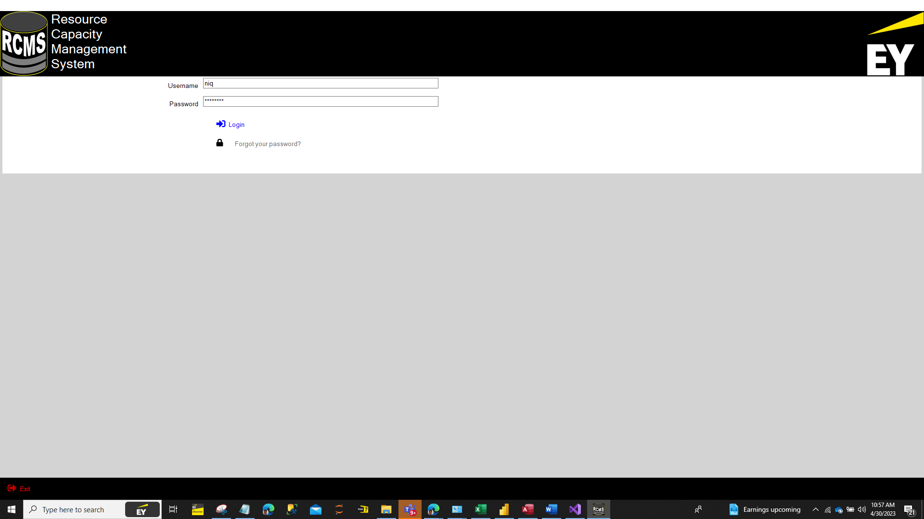

**Figure 4.2** *Log in Page of the Resource Capacity Management System*

The developed system has three types of users, the Task Administrator acting like a System admin, Users, and the Marketing Leaders. Figure 4.3 serve as the Landing page of after user log in. User authentication from the main server only occurs in for first time users. Once a user log in is recognize from the main server, a single sign on from the system will be activated to remember user log in credentials moving forward.

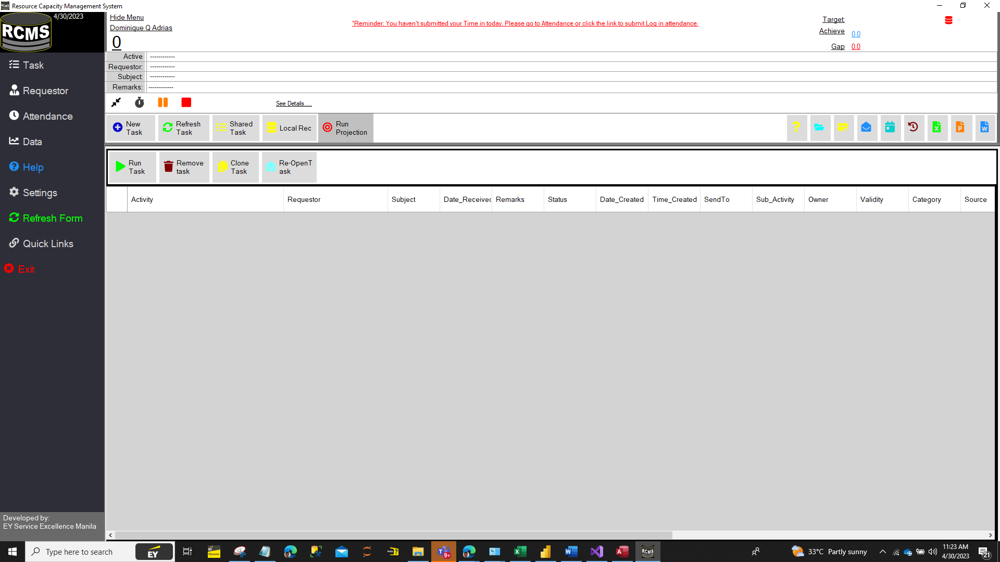

**Figure 4.3** *Landing Page of the Resource Capacity Management System*

The Landing page of the system give all types of users the same content. The design is the desired view of the system beneficiary and should also align with the organization brand and existing company applications. Admin, Staff and Managers can view the same frame whereas the system anyone who are asked to use the system should log all their activities regardless of what type of user access one has. Admin view is a distinct view in the setting module. Users from this page can already know his/her utilization rate for the day at the same time has leverage to efficiently manage his/her task in the landing page. Landing page is where other navigation buttons are shown to access the other features of the system.

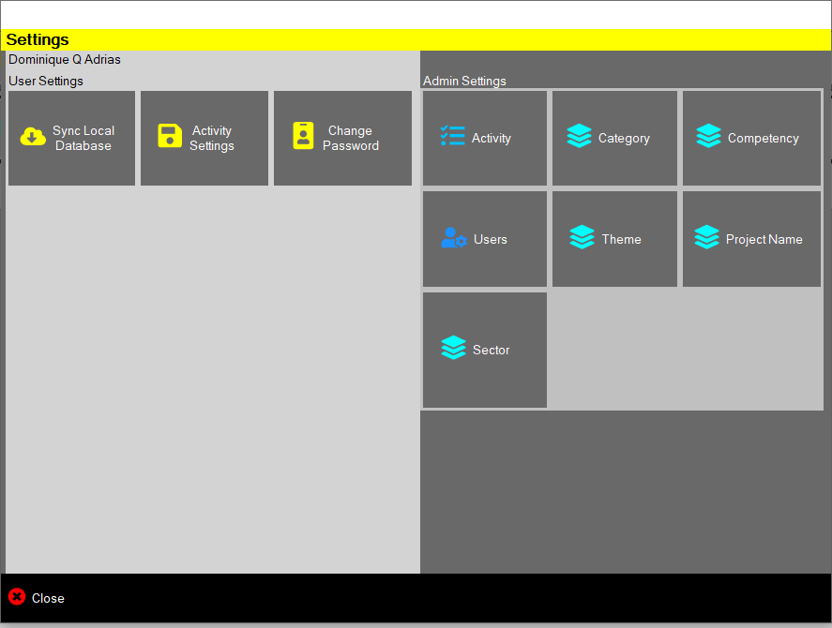

**Figure 4.4** *Task Administrator Interface of the Resource Capacity Management System*

Task Admin view has a dedicated space for non-Staff users where system setting can be configured directly by an Admin. This includes adding of new User, Activity, the different data dimensions of a utilization and the dashboard.

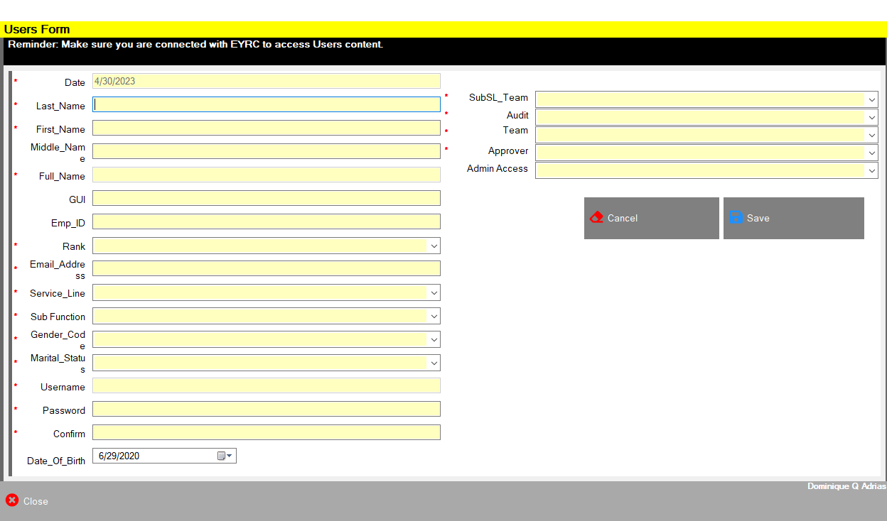

**Figure 4.5** *New User Creation Interface of the Resource Capacity Management System*

As shown in the figure 4.4, it is the Task Admin who has access to create and modify new and existing users. Important user details that need to be filled are those marked in red to satisfy and meet the data requirement for the Optimization Analysis. User information pass through a company’s private network that only recognized employees can access to impose data protection for personal information under the organization and national policies.

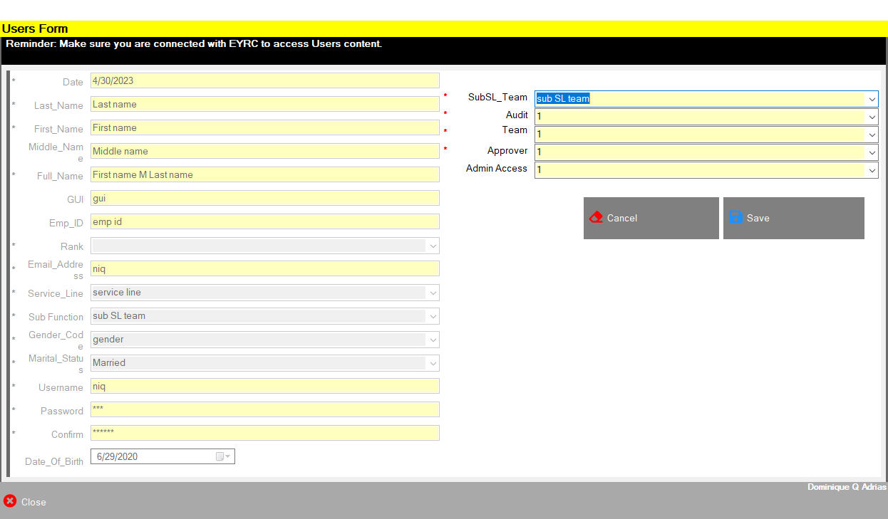

**Figure 4.6** *User Access Updation Interface of the Resource Capacity Management System*

As shown in Figure 4.5, the task administrator can modify user access by setting the value from the dropdown list. Value use for user having access is ‘1’ and ‘0’ for restricted access.

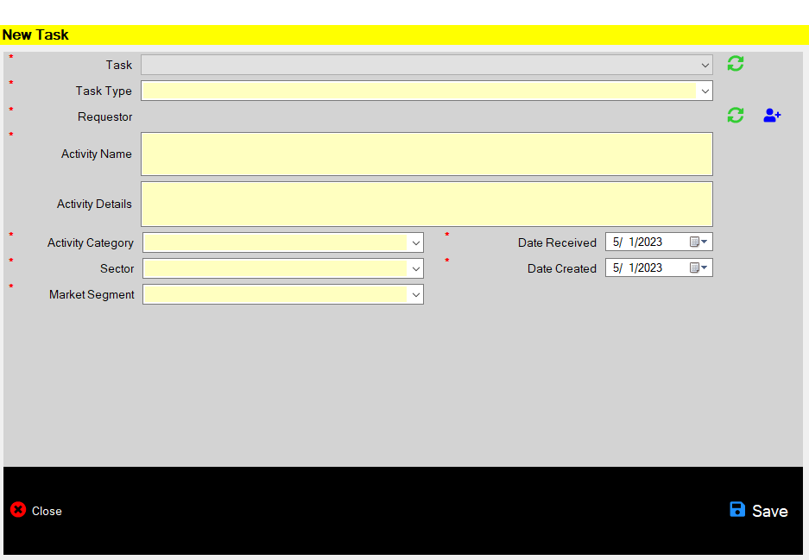

**Figure 4.7** *New Task Log Interface*

Figure 4.7 shows the form where users enter newly received or planned task. This view allows a user to fill he necessary data for the list of tasks he/she has such as Task name, Task type, Requestor, Activity name, Activity Details, Activity category, Sector and Market Segment, Date of task received, and the default value of Today for the Date created field. By clicking the save button, new task will be created and automatically added to user’s task list in the Main page show in Fig 4.3.

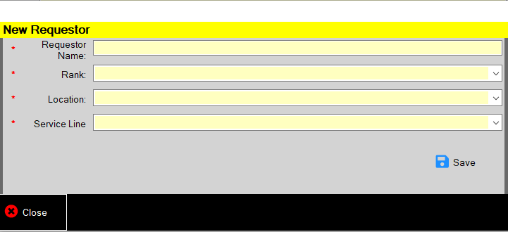

**Figure 4.8** *Adding of Requestor*

Figure 4.8 shows the form where to add new requestors that are not yet in the requestor’s list. Requestor information will be sourced in various application and platforms such as MS Outlook, Discover, Success Factor and other internal Employee database.

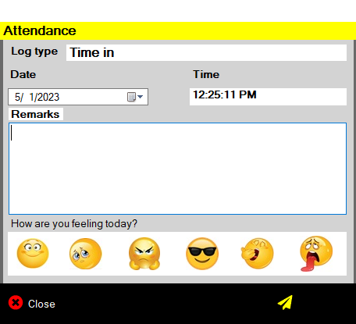

**Figure 4.9** *Attendance Logging Form*

Figure 4.9 shows the attendance form where time in is being captured with the user’s remarks and mood for the day.

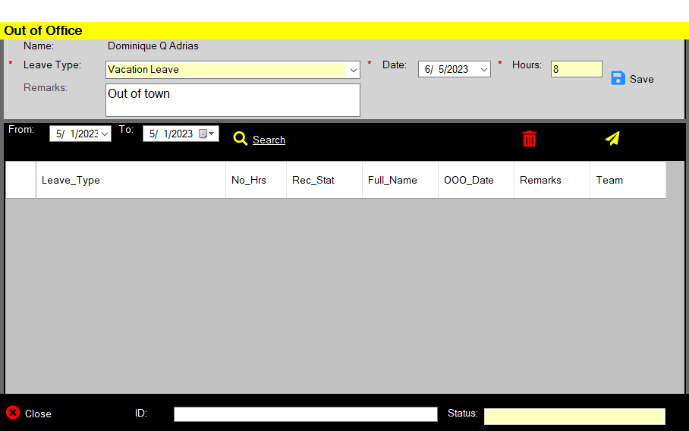

**Figure 4.10** *User Time Off Interface*

User are required to submit their planned and unplanned leaves to see the overall team capacity for a specific period. This is necessary for the Utilization dashboard as part of the utilization equation. User will fill the leave data and the equivalent or corresponding hours he/she will take for the leave data. This covers the assumption that users can also take his/her time offs not just a whole day leave but even a partial of hours from the date.

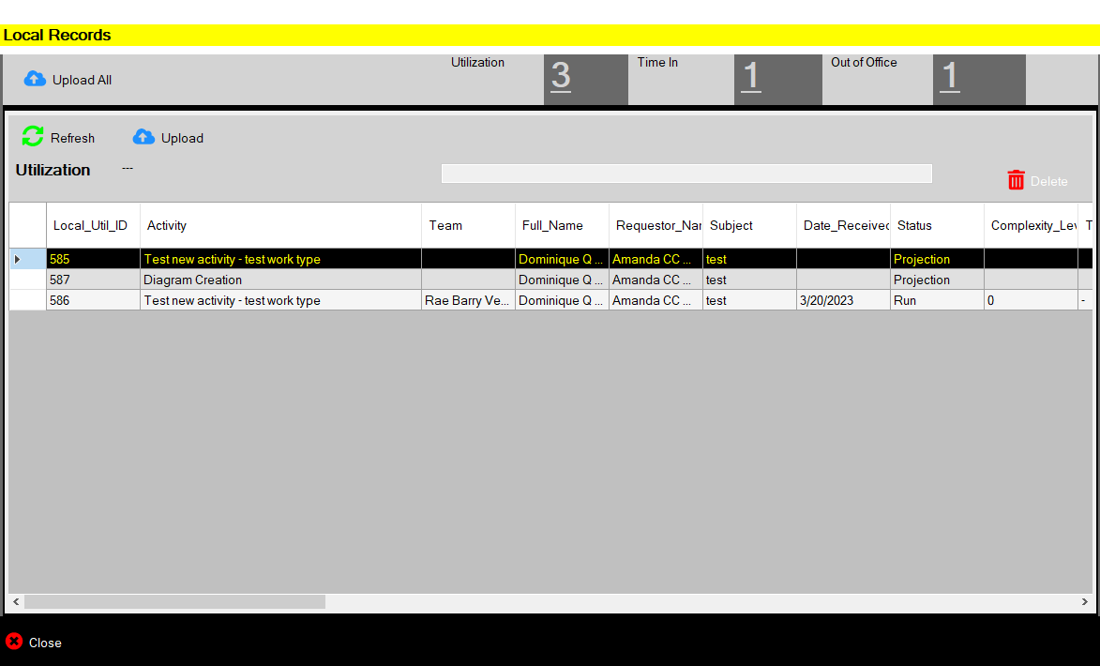

**Figure 4.11** *Local Records Interface*

Figure 4.11 is a local view of all records that are not yet uploaded in the Main database. Data that are store in users’ local machine are ready for data uploading to Azure SQL server. Data such as utilization, attendance and time offs will be reflected to the Utilization Dashboard once uploaded from local to Azure SQL database. Uploading of data can be in a batch order or segmented by the type of data like i.e., utilization data, attendance data and leave data. User should ensure he/she is connected to the organization’s private network during uploading.

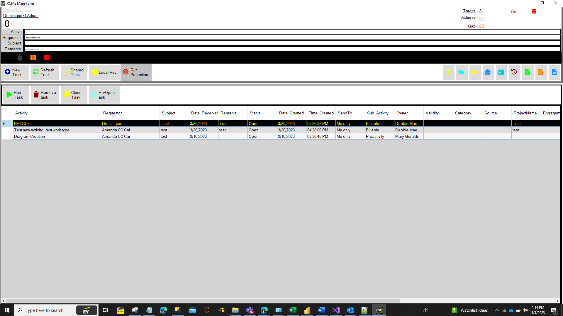

**Figure 4.12** *Main Page View 2*

Figure 4.12 is another type of view of the main page. This option hides the navigation menu from the left most are of the main page.

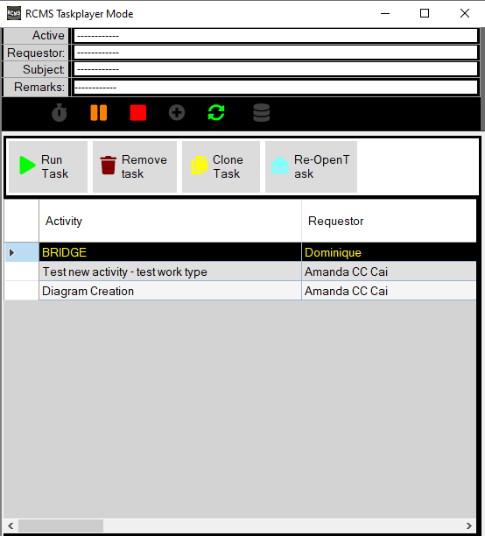

**Figure 4.13** *Main Page View 3*

Figure 4.13 is a compress view of the main page where only the list of task are shown for to easily navigate from other active windows.

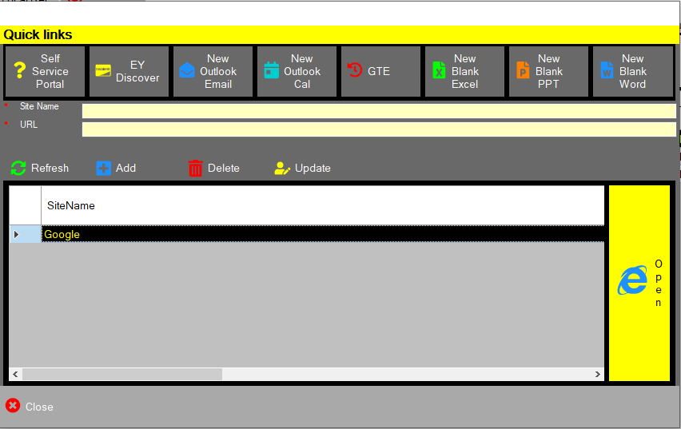



**Figure 4.14** *Quick Links Form*

Quick links window is an added feature of the system that had been integrated to other MS office products such as Outlook Email, Outlook Calendar, MS Excel, MS PPT, MS, Word and other in internal and external websites. The purpose is to create and open application by just adding or click the links automatically. Adding of web site's URL address for future reference is the same as having a bookmark from a browser to save time, which is useful for Web pages with long URLs or accessing a specific part of the site that might not be the main page for the site.

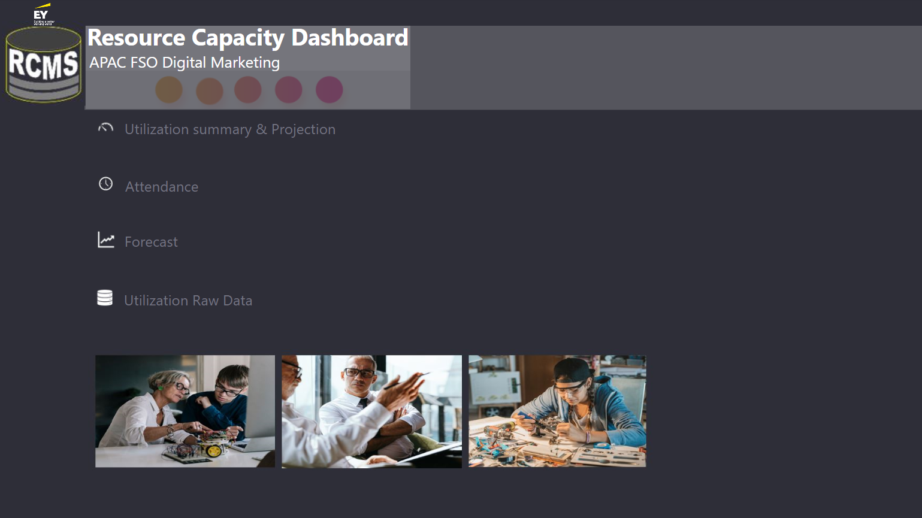

**Figure 4.15** *Dashboard Main Page Interface*

Figure 4.15 is the landing page for all report related to Utilization, Attendance, Leaves and other business insights that will help the management to optimize the resources to efficiently manage the capacity of the individual and team. The Dashboard landing page is where the navigation access can be found such as the report page for the Utilization & Projection, Attendance & Leaves, Utilization Forecast and the raw data ready for further analysis. The entire Utilization dashboard was developed in Microsoft power BI and deployed to Power BI web services that enable sharing of report and increase team collaboration in the Power BI Workspace. The application use connectors to source data from the database and automatically do the procedures written within the report. It has the capability to perform ETL processes on the scheduled time. In addition to its capability, complex calculation is done and executed from the application using DAX (Data Analysis Expression). Report visuals are all dynamic an customizable base on business analytics requirement.

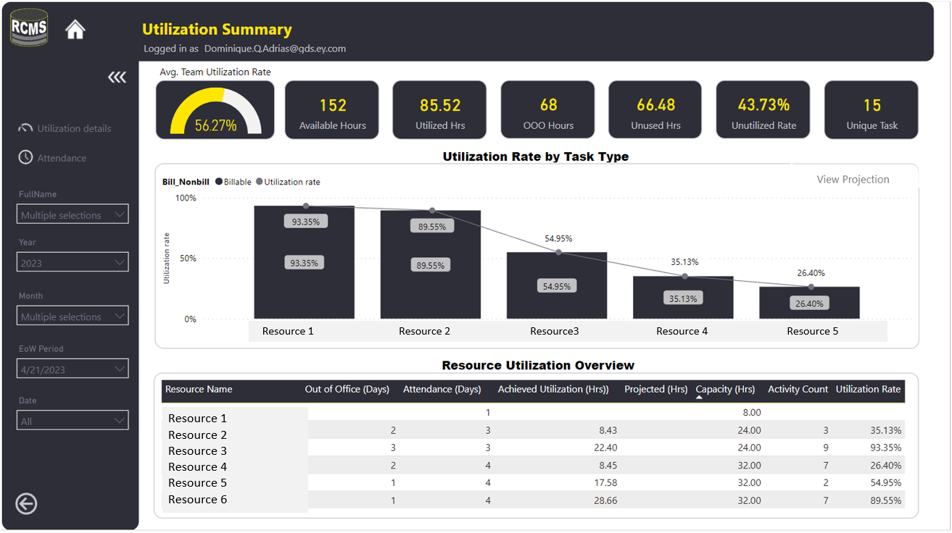

**Figure 4.16** *Utilization Summary Report*

Figure 4.16 shows the summary utilization performance of the entire team and individual as a resource. It is the page where leaders can see the high-level performance report containing the primary metrics of the business. Filters are place in the left pane of the report. Summary cards are located at the top part of the report. Navigation to collapse filters, main page, previous page and other report such as attendance and summary details are grouped in the left most of the report.

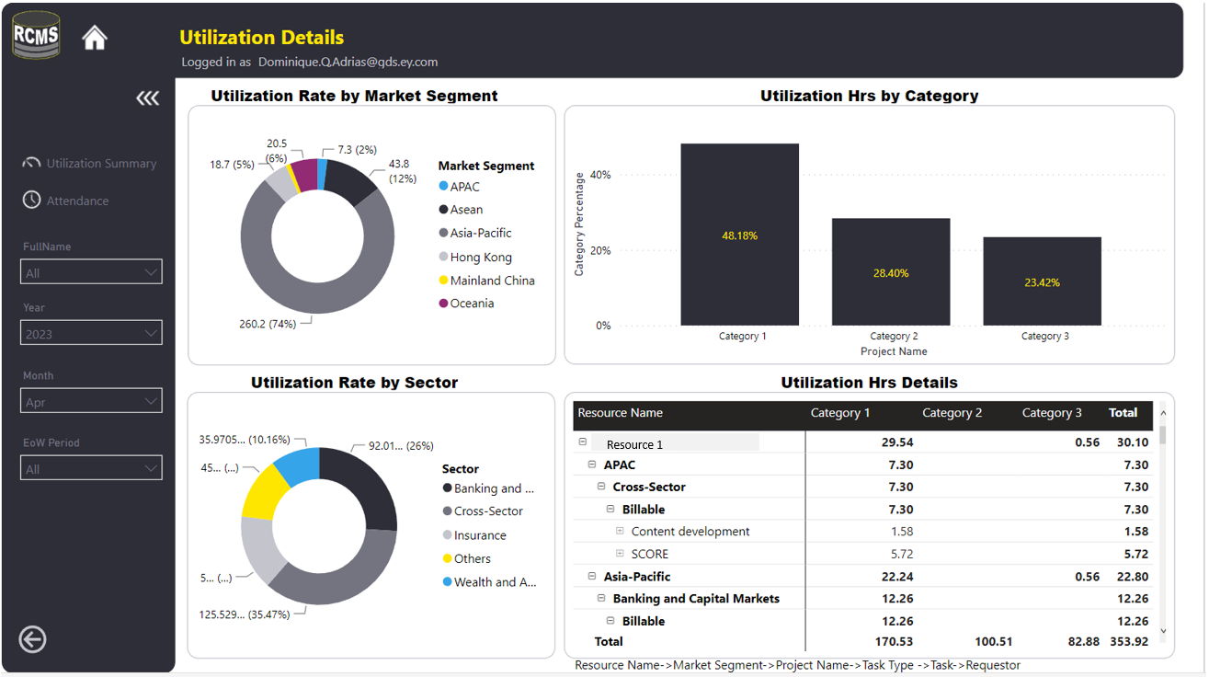

**Figure 4.17** *Utilization Details*

The Utilization details is the low-level presentation of a team or individual details. The report uses visuals like donut charts, clustered column chart and matrix table. Resources serves various market segments and sectors and categories for different activities. In this report, Leaders can see how much effort falls under these dimensions to have a deeper look at where time are spent.

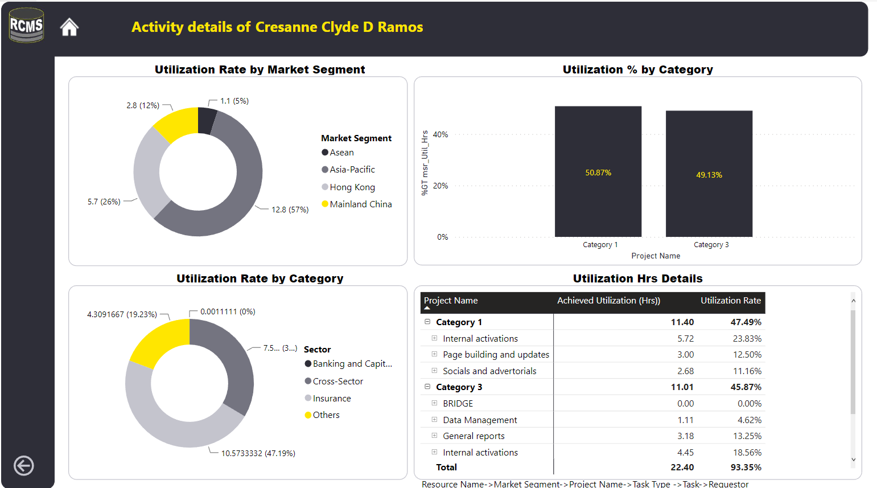

**Figure 4.18** *Activity Details of a Specific Resource*

The Utilization details is the low-level presentation of ana individual activity details. This view come from the Utilization summary report. To see specific resource’s utilization capacity, Leaders will select the resource name, right click, and select Activity details. Report view will automatically change and show the reports for that resource. It is using the same visual charts like what the Utilization detail report has.

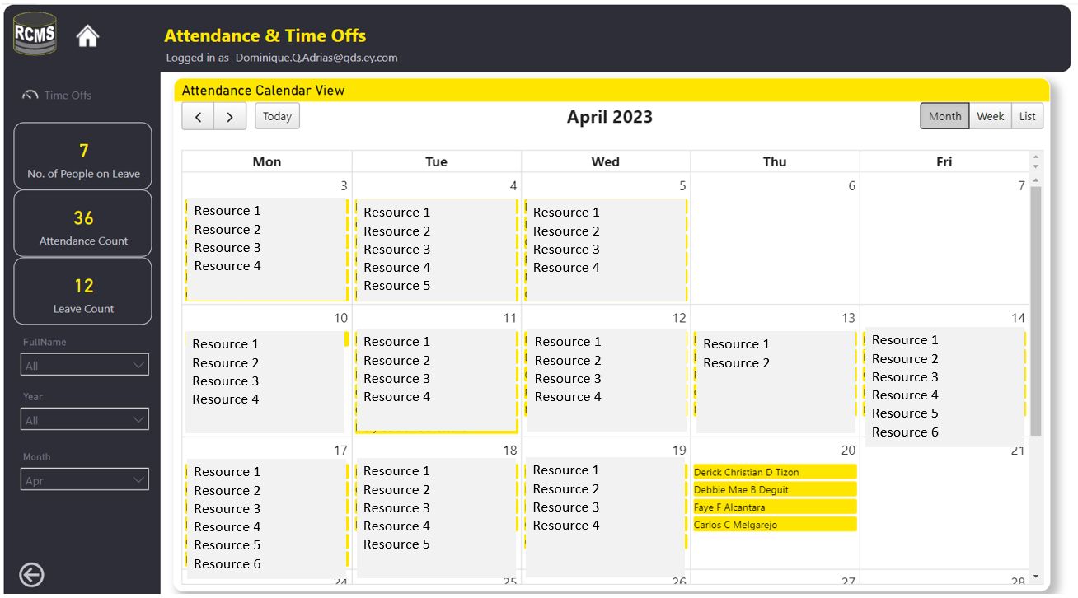

**Figure 4.19** *Attendance Report Calendar View*

The Attendance report calendar view is a visual presentation of the resources that have logged their attendance records on each working days excluding dates where they are on leave.

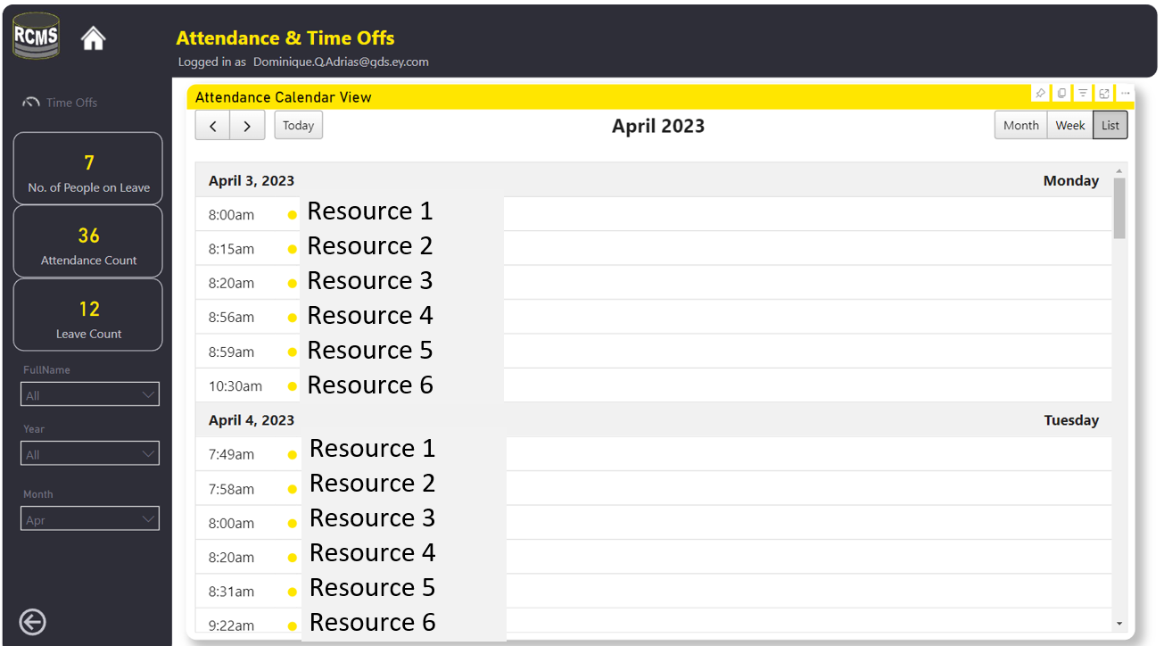

**Figure 4.20** *Attendance Report List View*

The Attendance report list view is a visual presentation of the resources that have logged their attendance records including the actual log in time. This is presented in a table like format.

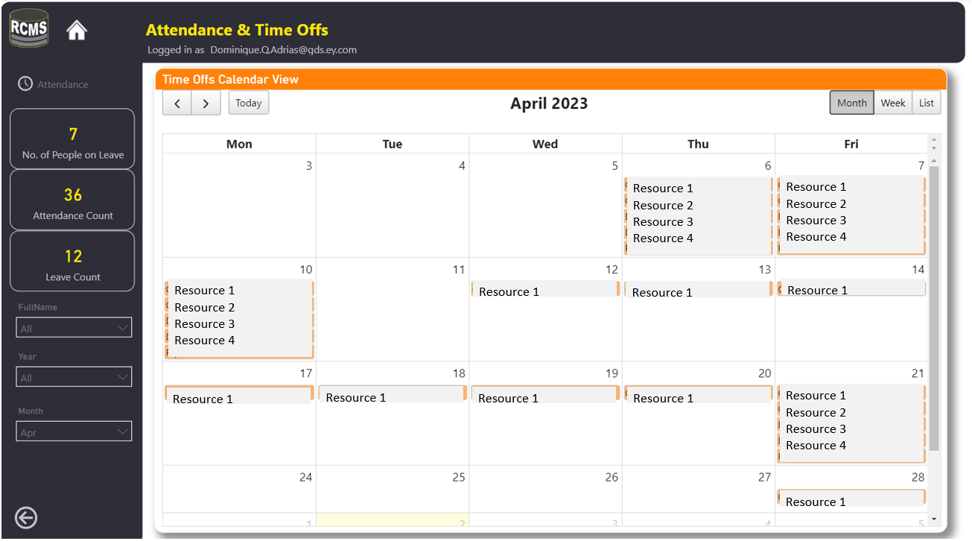

**Figure 4.21** *Leave Report Calendar View*

The Leave report calendar view is a visual presentation of the resources that have filed their leaves from the system Leaders can who’s out and will be able to know teams’ capacity in the coming dates.

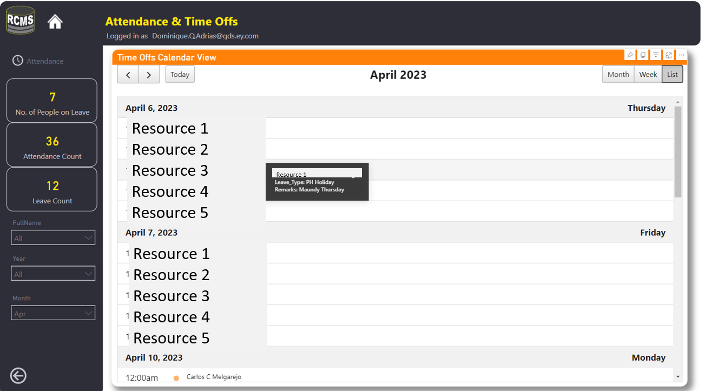

**Figure 4.22** *Leave Report List View*

The Leave report list view is a visual presentation of the resources that have filed their leaves from the system Leaders can who’s out and will be able to know teams’ capacity in the coming dates in a table format.

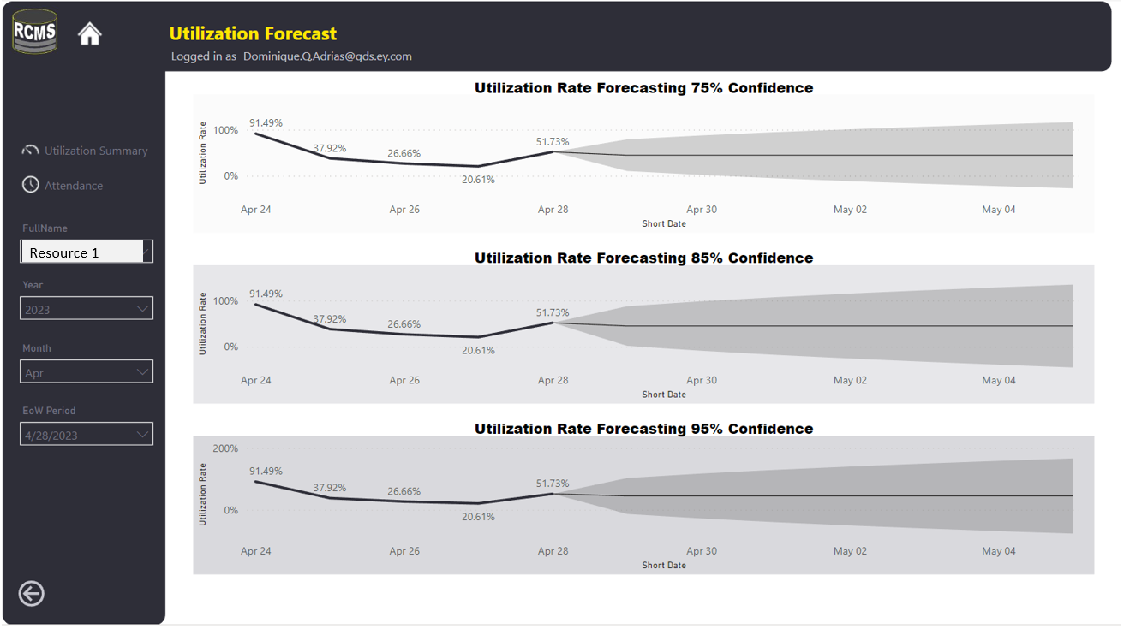

**Figure 4.23** *Utilization Forecast Report*

Utilization Forecasting report is a time series forecasting the utilization of a resource over time. This analysis uses the historical data bounded with time to and is using ARIMA as the statistical model for a specific resource or a team to predict its capacity in the coming days, weeks, or months. The report has 3 forecasting accuracy levels to give various option of the likelihood of the future capacity. With this insight, Leaders can have the glimpse of how the teams' capacity would look like. They can now plan and take further action to optimize their staffs

**Software and Hardware Specification**

**Table 4.23** *Minimum Hardware and Software Requirements of the system*

|  |  |
| --- | --- |
|  | **Specification** (Desktop Application) |
| Operating System | * Windows 8, Windows 10 or Higher |
| Special Software | * MS Power BI Desktop |
| Hardware | * Core-i5 Processor(CPU) with 2.30 gigahertz (GHz) frequency or above * A minimum of 8GB RAM * Monitor Resolution 1024x768 or higher * A minimum of 500GB available space on the hard disk * USB Keyboard and Mouse or some other compatible pointing device |
| Network | * Internet Connection Speed of at least 50MBps * EYRC VPN |
| Browsers | * Microsoft Edge * Chrome 36+ or |

It can be seen in Table 4.23 the minimum required hardware, software, and network specification of the Resource Capacity Management System. The system was developed using the .Net Framework capability of C# to enable system integration and improve program performance and security, the minimum requirements are the med level specifications of the default company laptop specification. Furthermore, installation, updates are managed within the company SharePoint site that are being controlled and accessed through the Organization’s private network.

**Presentation of Testing Results**

Testing and evaluation procedures were conducted after the development of the final prototype. The developed Resource Capacity Management System underwent a series of testing and in parallel to that is the modifying the code during addressing errors and failure to perform the required functions. Compatibility tests were done to different types of users. Since the system is a published as a desktop application, system compatibility is tested and worked well for all users. Installation of the exe file are managed through the organization’s security team given that it should go through a proper way of installing. All users are given the elevated rights to manually install the system without requiring for an IT personnel. However, anyone who are advised to use the software should provide the reason to install via admin security prompt access.

User Acceptance was successfully conducted. Pre-deployment stage, it was presented to the Managers, Task Administrator, Staffs and other Stakeholders. Acceptance was given as an approved and official system for EY Digital Marketing team, IT team and Cyber Security team.

Pre deployment and post deployment Customer Feedback Analysis were completed through a survey using a series of questions from Software Product Quality standards commonly known as ISO/IEC 25010. Findings are supported with data visualization and insights.

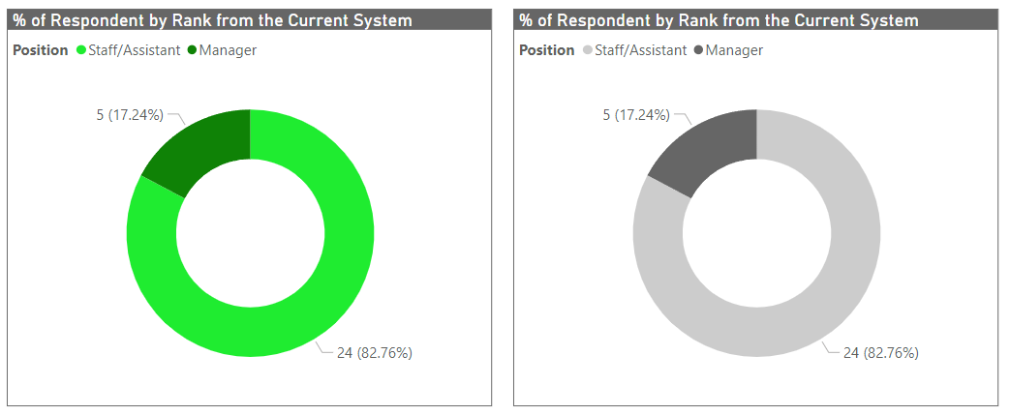**Figure 4.24** *Respondent by Position based on 60%of 8 Managers and 40% of 60 Staffs*

Figure 4.24 shows 17.24% of Managers Responded from the current system and the same number of managers responded to survey for the proposed system. In addition to that, the number of staff responded remain the same from the current and proposed system. Overall, there are total of 29 responses out of 68 targets. This means that the goal to get the percentage of respondents by position was successfully achieved.

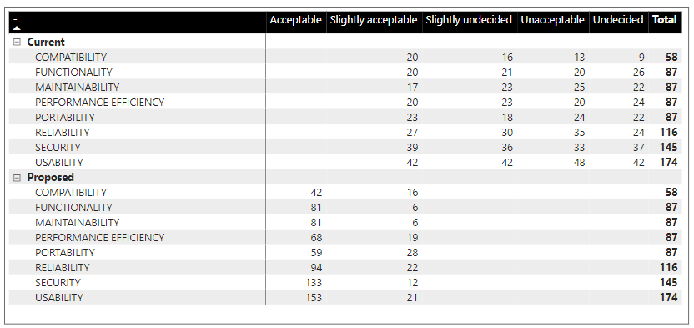

**Figure 4.25** *Respondent Summary Report of Current and Proposed System Standard Quality based on the total count of response using Likert Scale*

Figure 4.25 a summary of responses grouped by current and proposed system showing the comparative statistic of customer satisfaction from the old and new system.

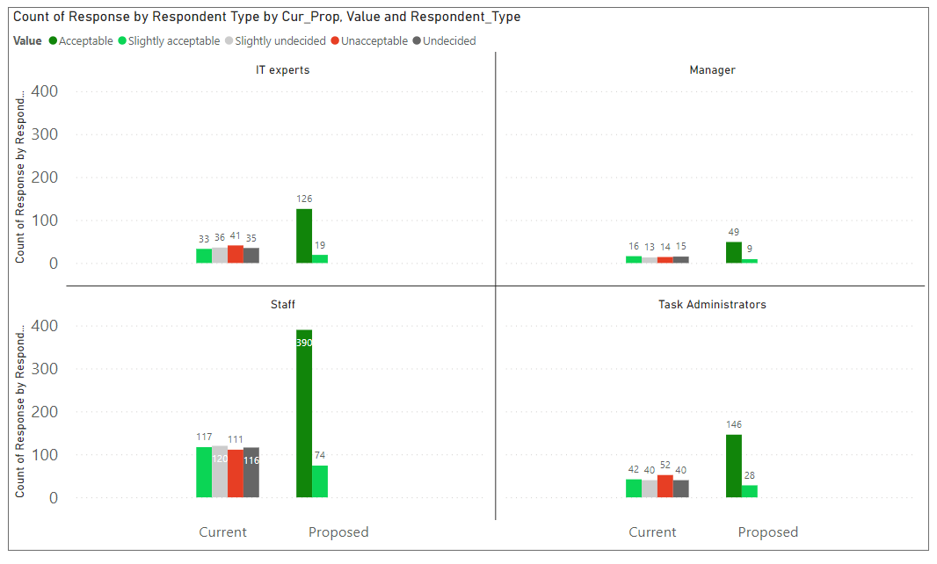

**Figure 4.26** *Respondent Summary Report of Current and Proposed System Standard Quality based on Respondent Type.*

The chart shows the highest respondent with highest Acceptable feedback came from Staffs as they are most of the users using the old and new system plus, they are the largest type of respondents.

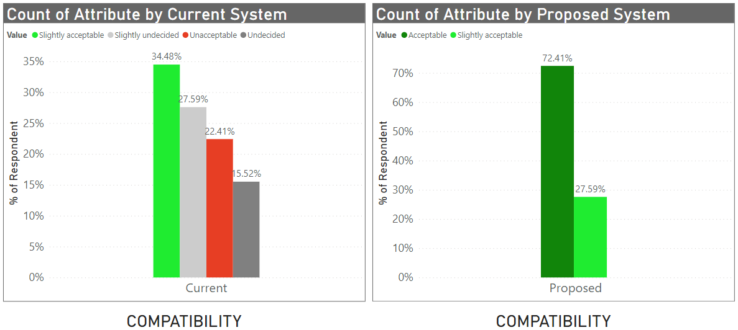**Figure 4.27** *System Compatibility of the Current and Proposed Result.*

The proposed system can efficiently perform the functions while sharing a common environment and resources with other applications, with no negative consequences for any other system.

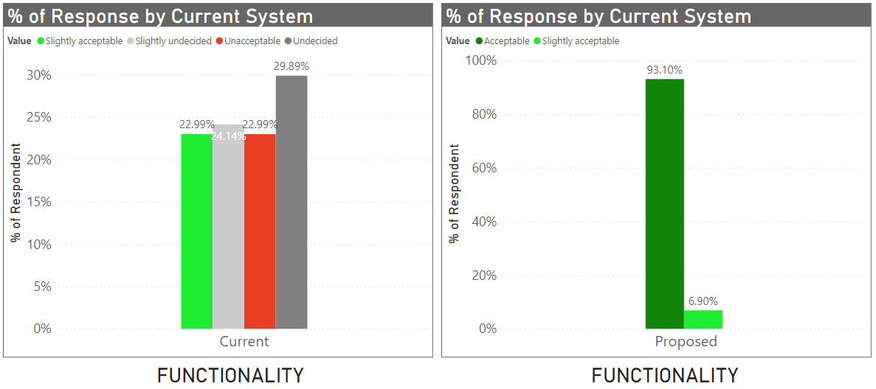

**Figure 4.28** *System Functionality of the Current and Proposed Result.*

All the tasks and objectives are covered by the proposed system. It provides accurate results, facilitates, and accomplish the specified tasks and objectives as observed by the users.

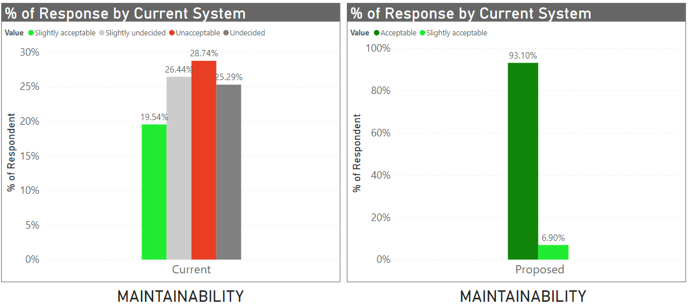

**Figure 4.29** *System Maintainability of the Current and Proposed Result.*

The proposed system has discrete components and has the ability to which a software can be used in more than one system or more than one computer. It shows the effectiveness of the system. well as to identify parts that need to be modified.

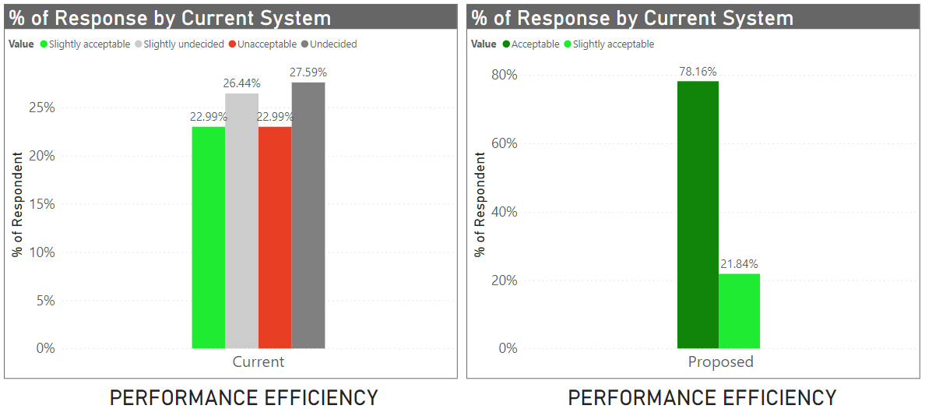

**Figure 4.30** *System Efficiency of the Current and Proposed Result.*

Users found the system as efficient as it should be. They can now efficiently manage task through the proposed system. It gives them less time manually tracking their task so they can focus on performing and delivering them. Majority of the respondents of the proposed system found it acceptable while the rest still accepted it.

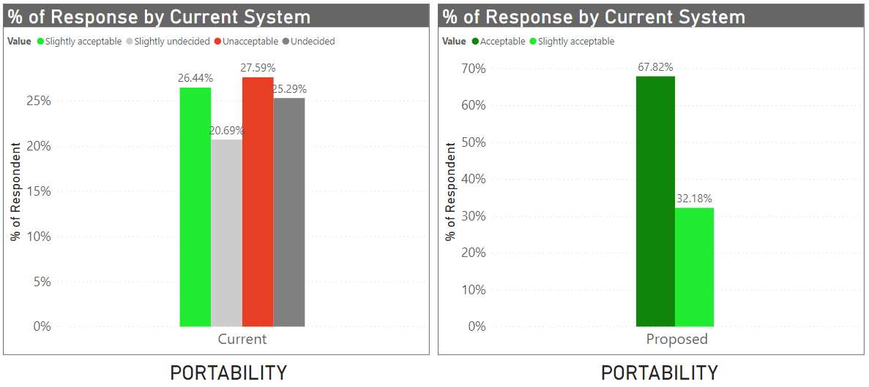

**Figure 4.30** *System Portability of the Current and Proposed Result.*

The proposed system can adapt in Windows operating system, hardware, software, and the overall default specification of user's machine. A proposed system can be successfully installed and/or uninstalled in a company’s system.

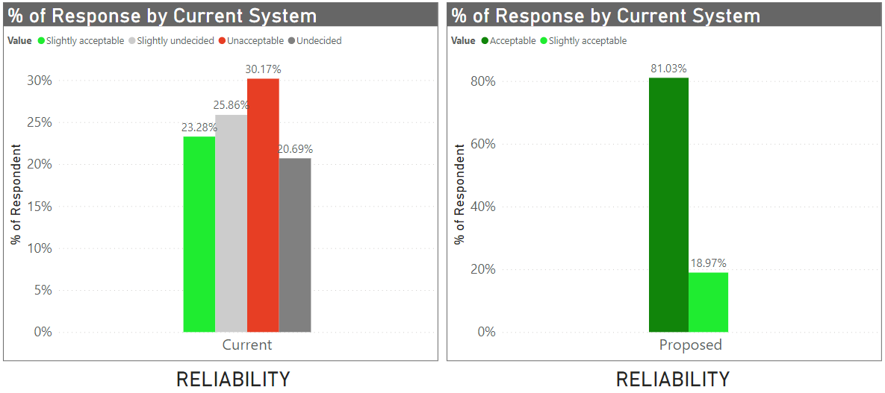

**Figure 4.31** *System Reliability of the Current and Proposed Result.*

In daily operation, the proposed system meets the requirements for reliability. Available whenever needed and accessible by a user. The proposed system can restore the original state and retrieve the data in an event of data loss.

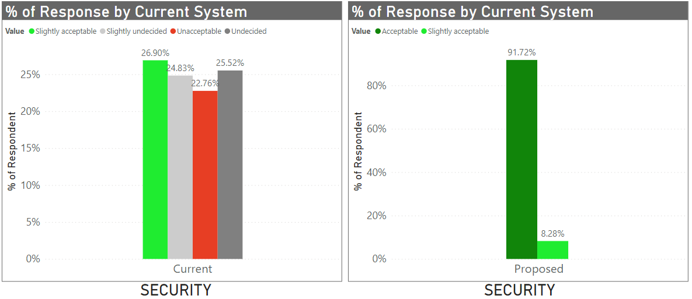

**Figure 4.32** *System Security of the Current and Proposed Result.*

The proposed system ensures that data are kept and stored in a secured file. It has the authenticity and integrity to ensure data are collected properly and can't be shared without access rights from the admin or data owner. The proposed system can track and monitor user activities through a historical record.

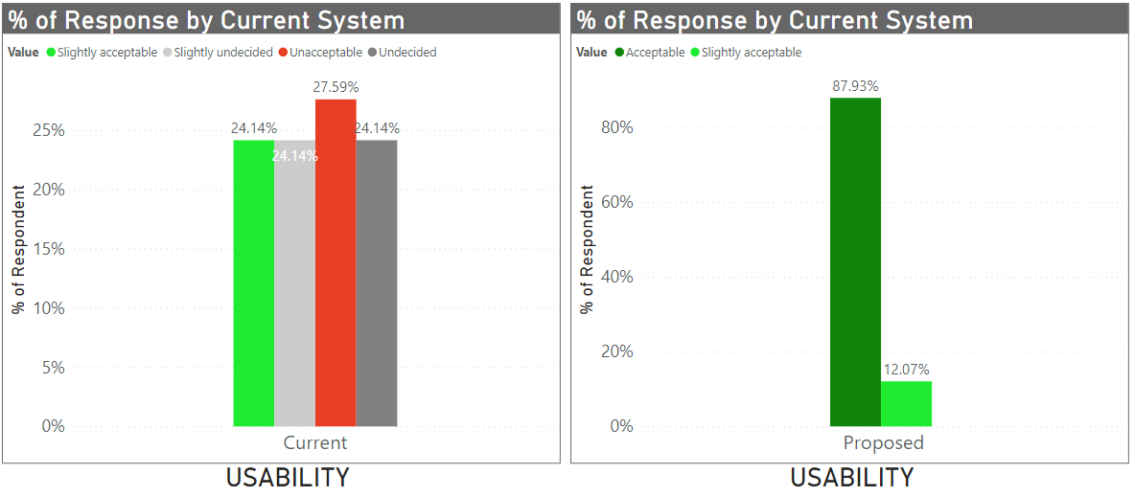

**Figure 4.32** *System Usability of the Current and Proposed Result.*

The proposed system is suitable for their business and users’ requirements. Learnability is high with the manuals that are provided to the users and the training conducted to them. The proposed system is easy to use and user friendly. The User interface give the users a satisfying interaction with the system.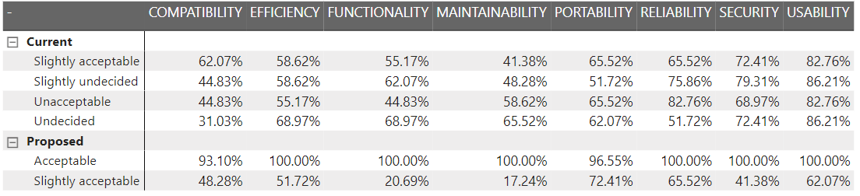

**Figure 4.33** *System Overall Percentage Result of the Current and Proposed System.*

Figure 4.33 shows that the proposed system is well accepted and approved by users. This means that the current system was successfully improved through the newly proposed system. Undergone the quality test, the system passed the expectation of the business and are ready to immerse into the new process with the help of RCMS.